How To Change Your Default Browser

- Pull up Google Chrome
- Click on the three dots on the right hand side 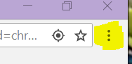
- Choose settings
- Find Search Engine and click the down arrow and choose Google.
- Then look at the Default Browser section and make sure it says Google. If not then you will change that area to Google also.

